LOUDON COUNTY

Employment, Job Training,
High School Equivalency Testing
& Adult Education

American Job Center - Lenoir City
Workforce Innovation and Opportunity Act (WIOA)
======================================================

Loudon County Health Department Dental Services
Mondays and half a day on Fridays.
Dental clinic for children up to age 21 for preventative dental (cleanings) and fillings.
Emergency dental care service for adults. Please call ahead to determine if there is a waiting list.
Loudon County Health Department
600 Rayder Avenue
Loudon, TN, 37774
Phone: 865-458-2662

Loudon County Public Libraries

Greenback Public Library
6889 Morganton Road
Greenback, TN 37742
Phone: (865) 856-2841

Loudon Public Library
210 River Road
Loudon, TN 37774
Phone: (865) 458-3161

Philadelphia Public Library
714 Thompson Street
Philadelphia, TN 37846
Phone: (865) 657-9059

The Public Library at Tellico Village
300 Irene Lane
Loudon, TN 37774
Phone: (865) 458-5199

-----------------------------------------------------------------------------------------------

Loudon County Department of Health
600 Rayder Ave.
Loudon TN 37774
865-458-2514

Department of Childrens' Services
Loudon County
485 Pine Top Street, Lenoir City, TN 37771
(865) 988-0398
TO REPORT CHILD ABUSE OR NEGLECT, CALL HOTLINE 1-877-237-0004

Department of Human Services
Louodn County
485 Pine Top Street, Lenoir City, TN 37771
(865) 986-4749

=======================================
FREE
Martial Arts Classes
in Loudon County for children & adults
Instructions focus on discipline, confidence, self respect, anti-bullying, self defense,
respect for authority, family togetherness and physical activity

For more information visit
Lenoir City Isshinryu Academy
on Facebook or call
Master, B. J. Frye 865-237-4692
Sensei, Daniel Ferguson 865-336-6175

==========================================

The Loudon County Clerk's Office
providing Driver's License Services
The Driver's License Office is located on the lower level of the Courthouse Annex.
It is open Monday thru Friday 8:00 to 4:00.
We are able to process the following: drivers license renewals, replacements,
address changes, name changes, identification cards and CDL downgrades.
For further information please call 458-2916.

================================================================
Loudon County Habitat for Humanity
(Housing Need)
NOW ACCEPTING APPLICATIONS
How can my family qualify for a Habitat home?
Call 865-458-0704
================================================================

Technology Access Program
A community Outreach Project of the Tellico Village Computer Users Club. Donated computer are
reconditioned and given away to students and families who do not have one in their household in efforts to improve computer literacy and provide academic support.
Phone: 865-332-5313

Emergency Food Pantries

Good Samaritan Center
119 A Street, Lenoir City
865-986-1777
&
505 Mulberry Street, Loudon
865-458-5541

New Life Family Worship Center
8735 Highway 72 N, Loudon
(865) 458-5300

Reed Springs Baptist Church
485 Reed Springs Church Road, Philadelphia
865-458-5813

The Refuge Church at Pleasant Hill
2144 Old Hwy 95, Lenoir City
865-986-7450

Cornerstone Church of God
12813 Hwy 11, Farragut
(East of Dixie Lee Junction)
865-966-2300

Four Paws (Emergency Food for Pets)
Good Samaritan Center
119 A Street, Lenoir City
865-986-1777

Loudon County
Community Advisory Board
Community minded persons are invited to fellowship and network with
other community partners to discuss efforts for assisting the communities and
families of Loudon County.
Date: Thursday, Oct 4, 2018
12:00 a.m.
Loudon County Technology Center/Family Resource Center
4380 Harrison Road, Lenoir City
Feel free to bring your lunch
For additional information please contact:
Cindy Purdy at 986-2036 ext 4615 or purdyc@loudoncounty.org
Shannon Forrester at 865-988-0398 ext 110 or shannon.forrester@tn.gov

******************************************************
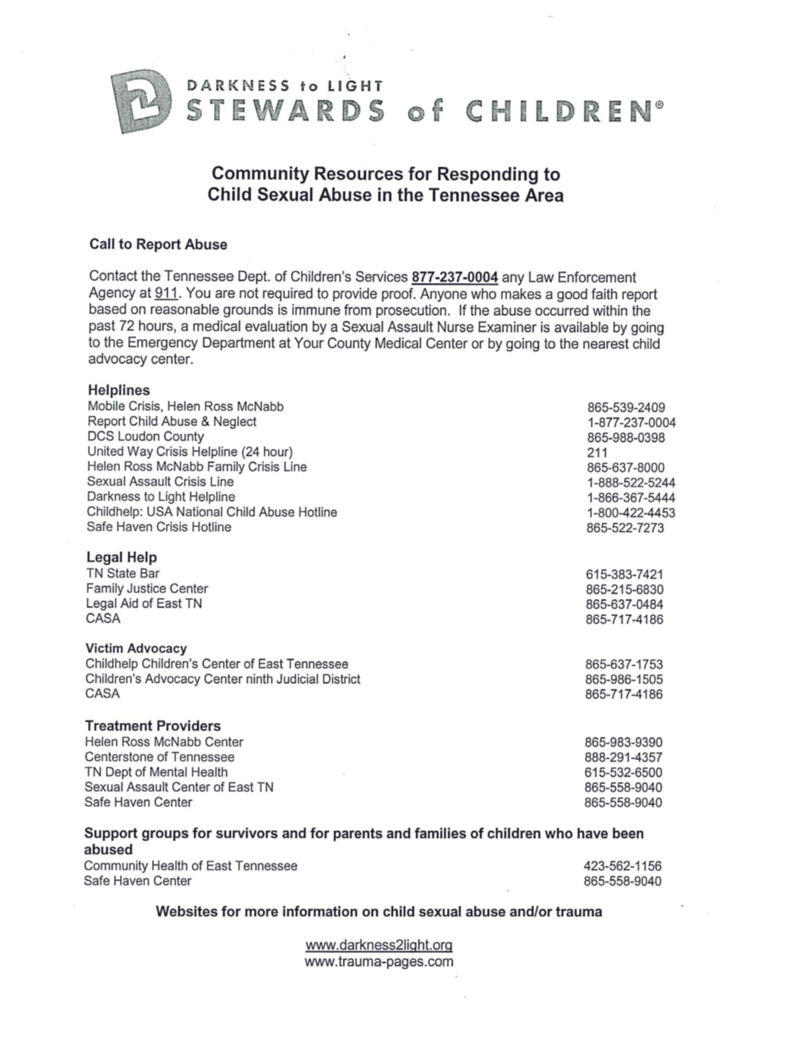
================================

Lions Clubs of Loudon County
Visual Screening & Eye Glasses Service

The Lions Clubs of Loudon, Lenoir City, and Tellico Village
coordinate their efforts to provide visual screenings and eye glasses for
economically disadvantaged children and adults within Loudon County.

Parents, caregivers and adults who are interested in receiving the
eye glass service please call the Lion’s Club representative at
865-458-5951
to schedule an application appointment to determine service eligibility.
The eye glass service is based on the poverty level guidelines.

Parents and caregivers are required to pay a $20 co-pay for each child,
which includes an eye exam and one pair of glasses.
All eye exams and glasses are purchased at the Walmart in Lenoir City.

*****************************************************************************

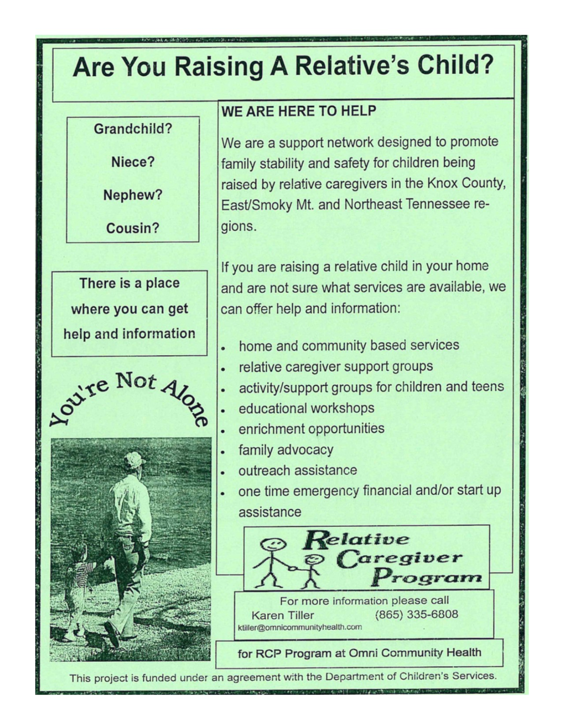

Good Samaritan Center
119 A Street, Lenoir City, TN 37771
Phone: 865-986-1777 Fax: 865-988-5625
Monday-Thursday, 9 am-12:30 pm
Thursday, 3:30-6 pm
Friday, 9 am-4 pm

505 Mulberry Street, Loudon 37774
Phone 865-458-5541
Monday & Wednesday, 10 a.m. - Noon

GSC is a private, non-profit assistance Ministry serving emergency
needs of people in Loudon County.

'''''''''''''''''''''''''''''''''''''''''''''''''''''''''''''''''''''''''''''''
Good Neighbors Shoppe
420 Leeper Parkway
Lenoir City, TN 37772
865-988-9925
Hours: 10:00 a.m. to 4:00 p.m. Tuesday thru Saturday
Non-profit upscale resale shop, reasonably priced and proceeds benefit Loudon County charities.

================================================================

Crisis Center for Women - IVAS
A domestic violence victims’ program providing protection,
advocacy and services to women and women with dependent children
who are victims of domestic abuse.
Crisis line 865-988-STOP (7867)
Toll free 866-239-0871

88888888888888888888888888888888888888888888888888888888

Mid-East Community Action Agency
Early Head Start and Head Start
(865) 988-5133 or 376-2308
Early Head Start and Head Start serving parents and pregnant mothers to children age 4.

How to Apply for TennCare
You must apply for TennCare through the Health Insurance Marketplace. Apply online at www.healthcare.gov.
Printable application can be found online
English
https://marketplace.cms.gov/applications-and-forms/marketplace-application-for-family.pdf
Spanish
https://marketplace.cms.gov/applications-and-forms/marketplace-consumer-application-family-spanish.pdf
To get help with applying for TennCare call
1-800-318-2596
Do not have a computer and/or internet access you can apply at a kiosk within your local Department of Human Services (DHS) office.
Loudon County – Department of Human Services
485 Pinetop Street
Lenoir City, TN 37772-6343
Phone: (865) 986-4751
Additional Information can be found at
https://www.tn.gov/tenncare/members-applicants/how-do-i-apply-for-tenncare.html

==============================================================
Click to visit: www.kidcentraltn.com
.....................................................................................

Loudon County Education Foundation
www.lceftn.org
318 Angel Row
P. O. Box 430
Loudon, TN 37774
Ph: (865) 458-8749
Fx: (865) 458-1206

Project Lifesaver
Loudon County Sheriff's Office provides Project Lifesaver bracelets free of charge to families of autistic children that have a tendency to wander. For more information please contact
Debbie Hines
865-988-2300
Loudon County Sheriff's Office
12680 Highway 11 W, Suite 1
Lenoir City

===============================================
211 Tennessee
One of the easiest ways to get help is by dialing 2-1-1, Tennessee’s community services help line. When you call, you’ll get a real person, one who is trained to help you sort out your needs, and then give you phone numbers and addresses of the closest places where you can get help. 2-1-1 has a database of more than 10,000 health and human services programs, cross-referenced for all sorts of keywords. So don’t worry if you don’t know what type of service you need or the name of an agency — just talk with the specialist at the other end of the line and she or he can help you find what you need. All calls are free and completely confidential.
Hours of Operation: 24/7
Phone: 866-588-4211
Teleinterpreter available
http://tn211.mycommunitypt.com/﻿

=============================================
Mid-East Community Action Agency
Helping People/Changing Lives
(865) 986-5212
Services:
Medical Assistance
*Newly prescribed medications for individuals who have no medical insurance.
Utility Assistance
*Utility assistance is available through various grants such as the Low Income Home Energy Assistance Program (LIHEAP) and Ft. Loudoun Electric Corp.
Food
* Baby Formula
*Food voucher to local grocery store
*USDA Commodities distributes surplus foods on a quarterly basis. May consist of canned fruits, vegetables,meats and dried beans (etc...)

Homeless Services
*Homeless Letters may assist household in placement on waiting lists with participating housing authorities.
*Rental and/or Utility Deposits are available to homeless households who obtain housing with the means to maintain the housing unit.
*Motel rooms for burn out victims, other extending circumstances may be considered.
*Rental assistance is available to households who are facing a homeless situation.
Elderly Services
*Purchase a VRI Emergency Response Unit to maintain independence and maintain safety.
*Eye Glasses and Exam.
*Nutritional supplements prescribed by doctor. Such as boost, ensure and diabetic drinks.
*Meals on Wheels deliver hot nutritious meals daily.
Early Head Start and Head Start .(865) 376-2308
Early Head Start and Head Start serving pregnant mothers to children age 4.
All services listed above are subject to change without notice. Individuals or households must meet program eligibility and assistance is based on available funding.

Homeless and need help filing for disability?
Legal Aid of East Tennessee recently received a Department of Housing and Urban Development grant to provide the new SOAR Program. SOAR allows free legal assistance in filing disability claims for homeless individuals.
Call Legal Aid of East Tennessee for additional information.
(865) 637-0484

